**Name:** Syed Asad Abrar

**Roll No:** 16L-4292

**Section:** C

**Software Testing Assignment 1**

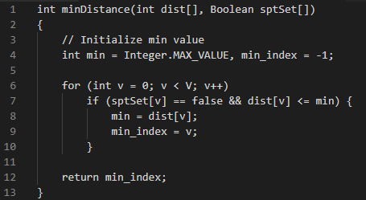

**a) Control Flow graph:**

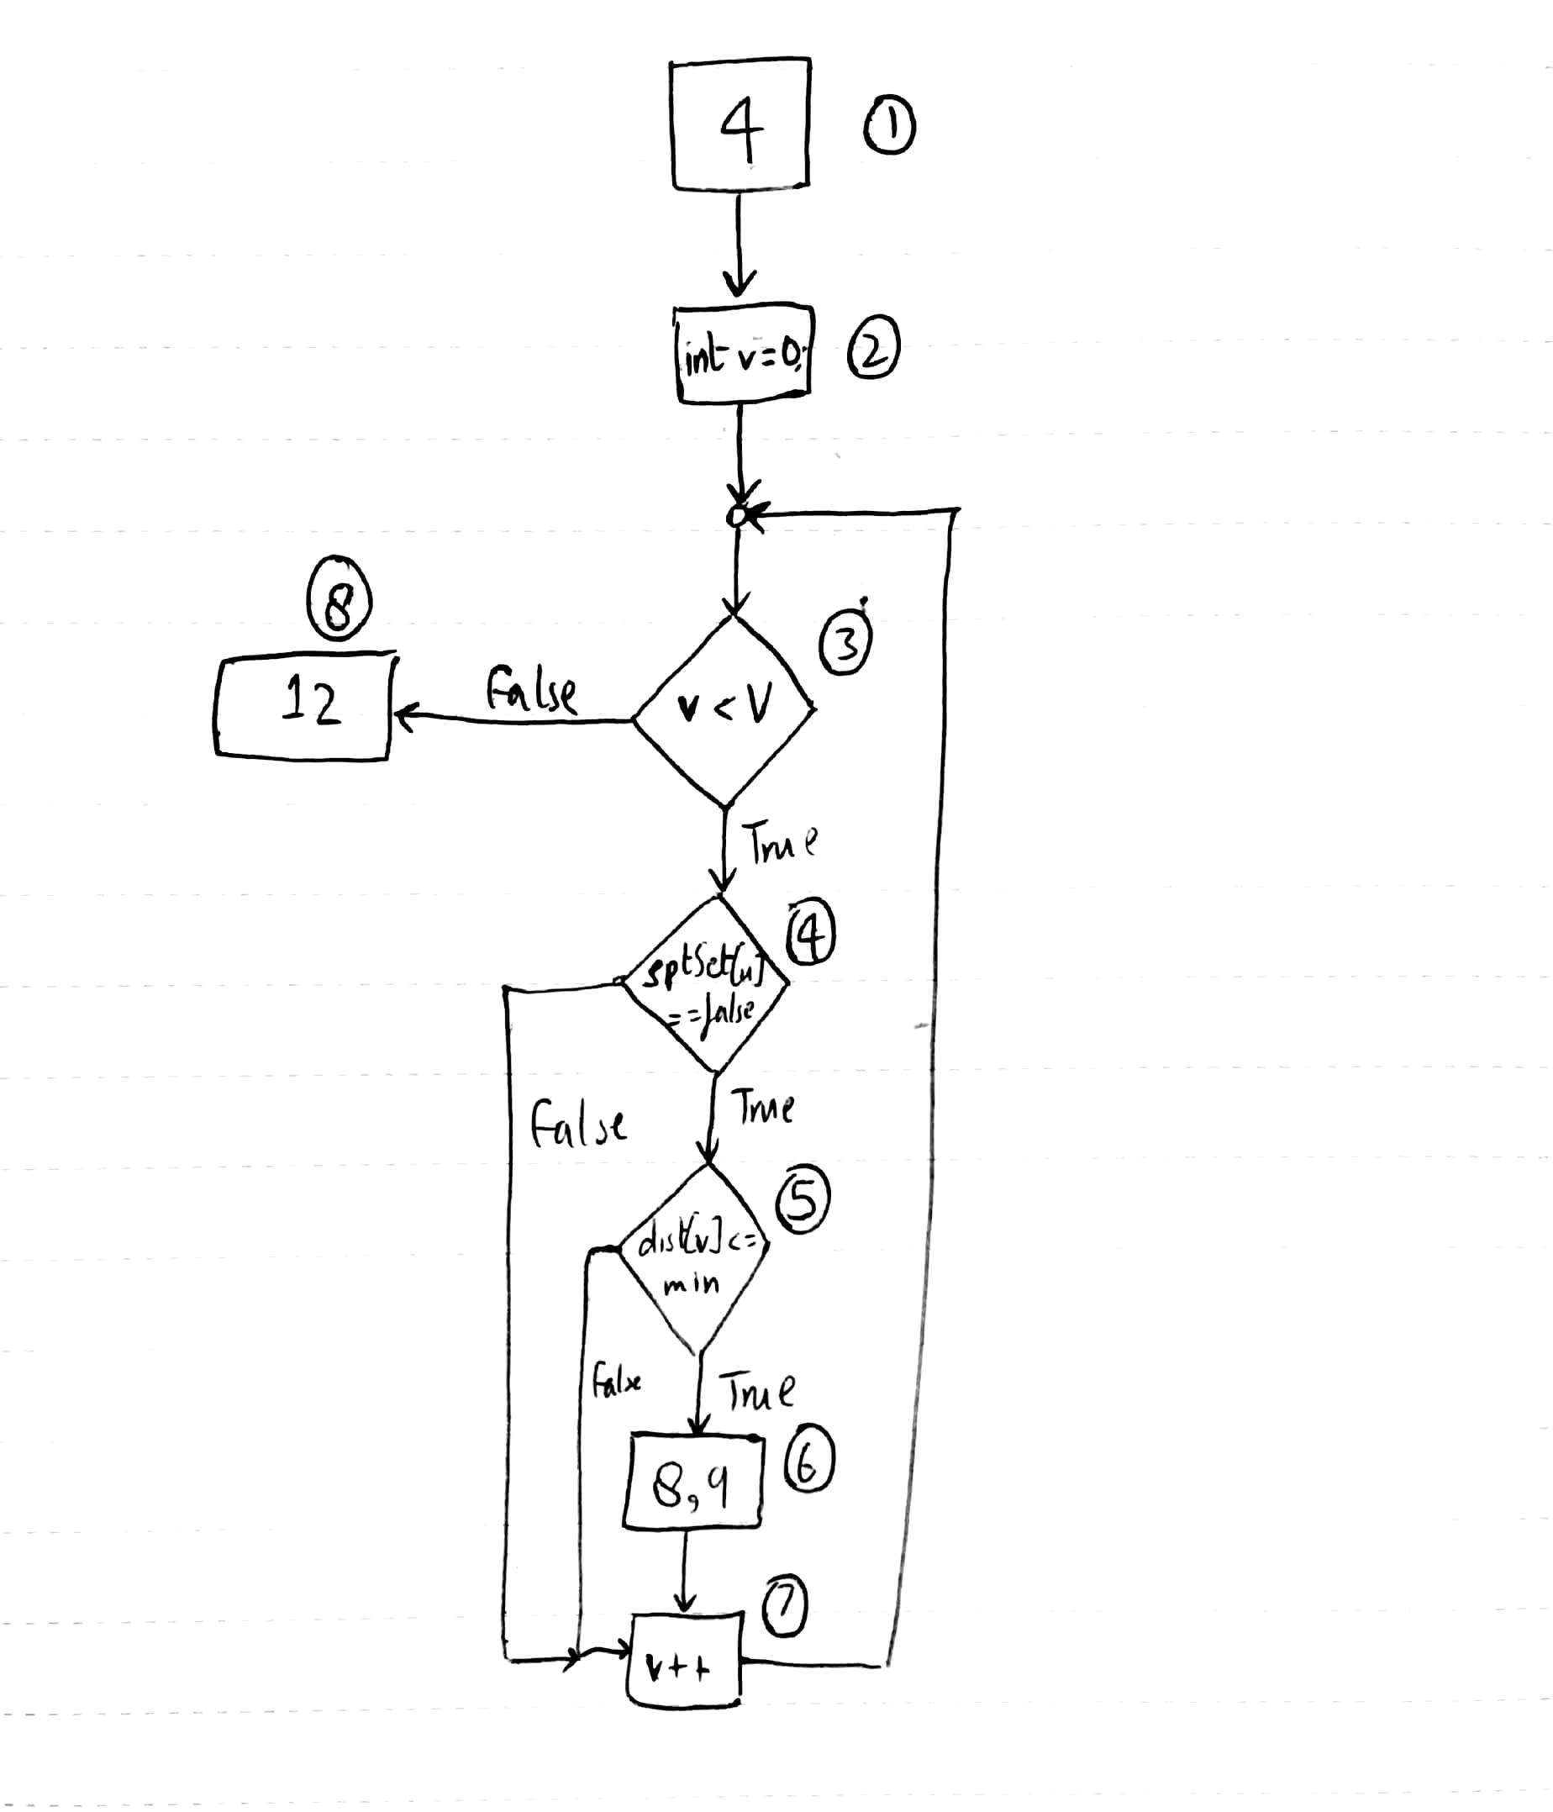

**b) Cyclomatic Complexity:**

E - N + 2 = 10 - 8 + 2 = 4

**c) i) Statement Coverage:**

* 1 -> 2 -> 3(T)-> 4(T) -> 5(T) -> 6 -> 7 -> 3(F) -> 8

**ii) Branch Coverage:**

* 1 -> 2 -> 3(T) -> 4(T) -> 5(T) -> 6 -> 7 -> 3(F) -> 8
* 1 -> 2 -> 3(F) -> 8
* 1 -> 2 -> 3(T) -> 4(F) -> 7 -> 3(F) -> 8
* 1 -> 2 -> 3(T)-> 4(T) -> 5(F) -> 7 -> 3(F) -> 8

**iii) Basis Path Coverage:**

* 1 -> 2 -> 3(T) -> 4(T) -> 5(T) -> 6 -> 7 -> 3(F) -> 8
* 1 -> 2 -> 3(F) -> 8
* 1 -> 2 -> 3(T) -> 4(F) -> 7 -> 3(F) -> 8
* 1 -> 2 -> 3(T)-> 4(T) -> 5(F) -> 7 -> 3(F) -> 8

**d) Infeasible paths:** No

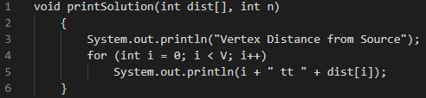

**a) Control Flow graph**

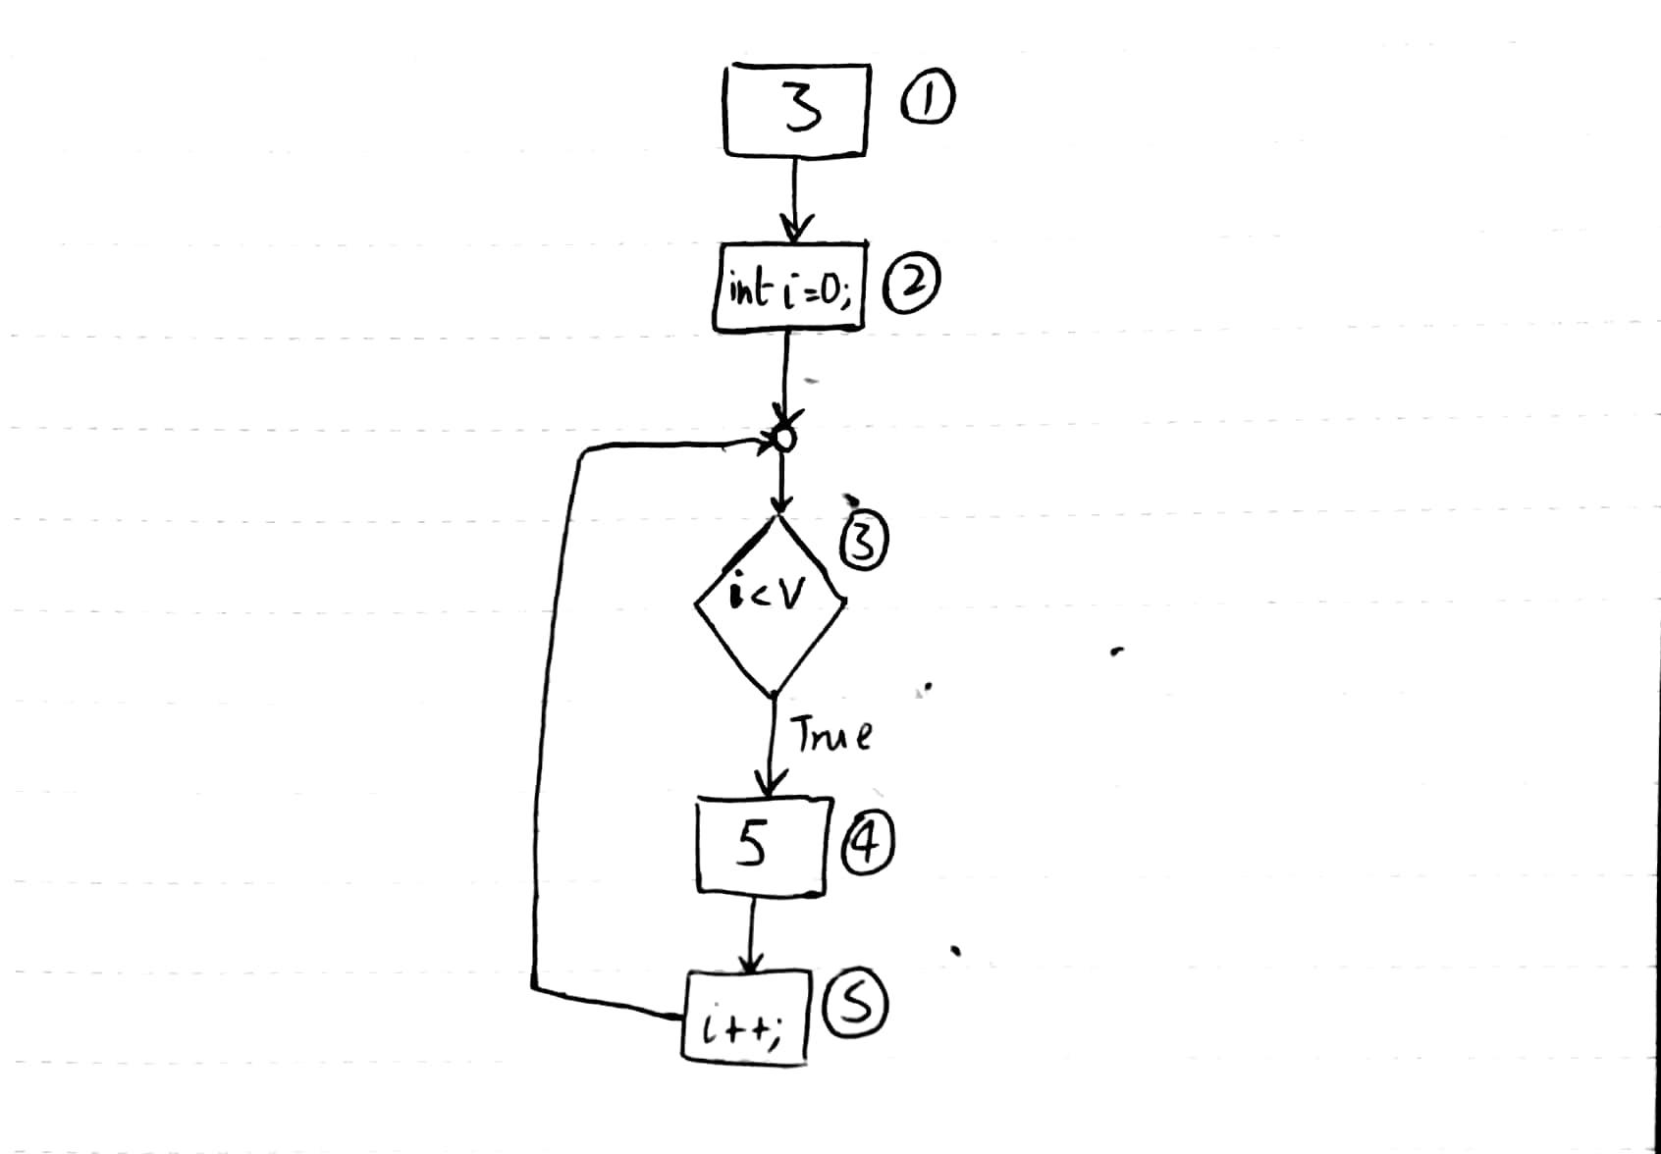

**b) Cyclomatic Complexity:**

E - N + 2 = 5 - 5 + 2 = 2

**c) i) Statement Coverage:**

* 1 -> 2 -> 3(T) -> 4 -> 5 -> 3(F)

**ii) Branch Coverage:**

* 1 -> 2 -> 3(T) -> 4 -> 5 -> 3(F)
* 1 -> 2 -> 3(F)

**iii) Basis Path Coverage:**

* 1 -> 2 -> 3(T) -> 4 -> 5 -> 3(F)
* 1 -> 2 -> 3(F)

**d)** **Infeasible paths:** No

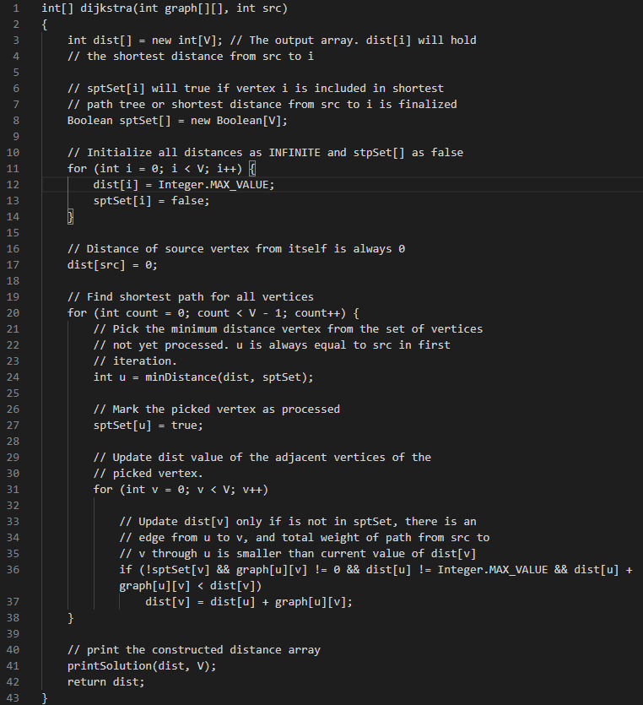

**a)**  **Control Flow graph:**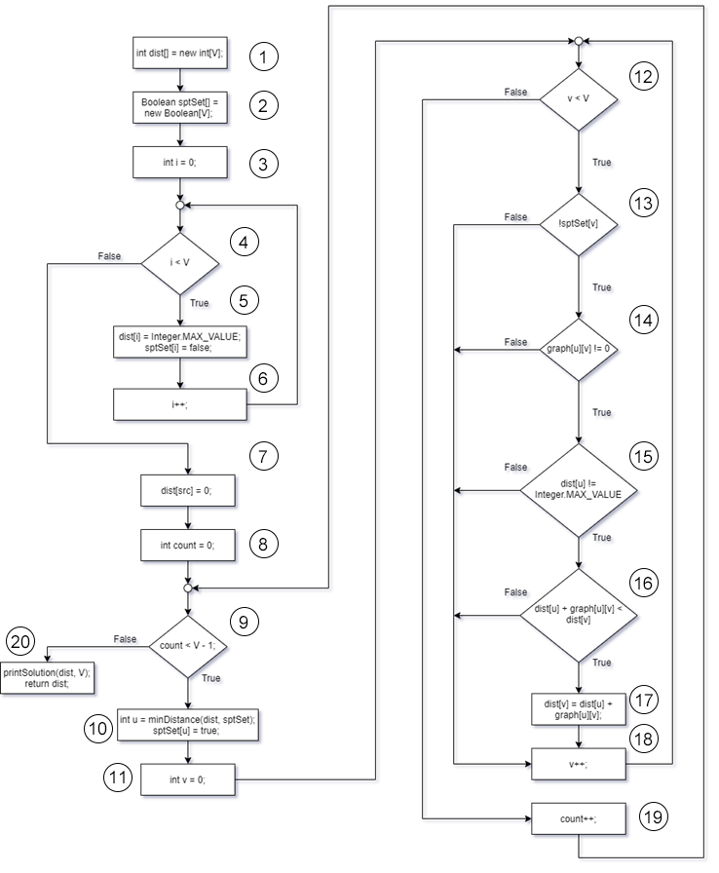

**b) Cyclomatic Complexity:**

E - N + 2 = 26 - 20 + 2 = 8

**c) i) Statement Coverage:**

* 1 -> 2 -> 3 -> 4(T) -> 5 -> 6 -> 4(F) -> 7 -> 8 -> 9(T) -> 10 -> 11 -> 12(T) -> 13(T) -> 14(T) -> 15(T) -> 16(T) -> 17 -> 18 -> 12(F) -> 19 -> 9(F) -> 20

**ii) Branch Coverage:**

* 1 -> 2 -> 3 -> 4(T) -> 5 -> 6 -> 4(F) -> 7 -> 8 -> 9(T) -> 10 -> 11 -> 12(T) -> 13(T) -> 14(T) -> 15(T) -> 16(T) -> 17 -> 18 -> 12(F) -> 19 -> 9(F) -> 20
* 1 -> 2 -> 3 -> 4(T) -> 5 -> 6 -> 4(F) -> 7 -> 8 -> 9(T) -> 10 -> 11 -> 12(T) -> 13(T) -> 14(T) -> 15(T) -> 16(F) -> 18 -> 12(F) -> 19 -> 9(F) -> 20
* 1 -> 2 -> 3 -> 4(T) -> 5 -> 6 -> 4(F) -> 7 -> 8 -> 9(T) -> 10 -> 11 -> 12(T) -> 13(T) -> 14(T) -> 15(F) -> 18 -> 12(F) -> 19 -> 9(F) -> 20
* 1 -> 2 -> 3 -> 4(T) -> 5 -> 6 -> 4(F) -> 7 -> 8 -> 9(T) -> 10 -> 11 -> 12(T) -> 13(T) -> 14(F) -> 18 -> 12(F) -> 19 -> 9(F) -> 20
* 1 -> 2 -> 3 -> 4(T) -> 5 -> 6 -> 4(F) -> 7 -> 8 -> 9(T) -> 10 -> 11 -> 12(T) -> 13(F) -> 18 -> 12(F) -> 19 -> 9(F) -> 20

**iii) Basis Path Coverage:**

* 1 -> 2 -> 3 -> 4(T) -> 5 -> 6 -> 4(F) -> 7 -> 8 -> 9(T) -> 10 -> 11 -> 12(T) -> 13(T) -> 14(T) -> 15(T) -> 16(T) -> 17 -> 18 -> 12(F) -> 19 -> 9(F) -> 20
* 1 -> 2 -> 3 -> 4(T) -> 5 -> 6 -> 4(F) -> 7 -> 8 -> 9(T) -> 10 -> 11 -> 12(T) -> 13(T) -> 14(T) -> 15(T) -> 16(F) -> 18 -> 12(F) -> 19 -> 9(F) -> 20
* 1 -> 2 -> 3 -> 4(T) -> 5 -> 6 -> 4(F) -> 7 -> 8 -> 9(T) -> 10 -> 11 -> 12(T) -> 13(T) -> 14(T) -> 15(F) -> 18 -> 12(F) -> 19 -> 9(F) -> 20
* 1 -> 2 -> 3 -> 4(T) -> 5 -> 6 -> 4(F) -> 7 -> 8 -> 9(T) -> 10 -> 11 -> 12(T) -> 13(T) -> 14(F) -> 18 -> 12(F) -> 19 -> 9(F) -> 20
* 1 -> 2 -> 3 -> 4(T) -> 5 -> 6 -> 4(F) -> 7 -> 8 -> 9(T) -> 10 -> 11 -> 12(T) -> 13(F) -> 18 -> 12(F) -> 19 -> 9(F) -> 20

**d) Infeasible paths:**

* 1 -> 2 -> 3 -> 4(T) -> 5 -> 6 -> 4(F) -> 7 -> 8 -> 9(T) -> 10 -> 11 -> 12(F) -> 19 -> 9(F) -> 20
* 1 -> 2 -> 3 -> 4(T) -> 5 -> 6 -> 4(F) -> 7 -> 8 -> 9(F) -> 20
* 1 -> 2 -> 3 -> 4(F) -> 7 -> 8 -> 9(T) -> 10 -> 11 -> 12(T) -> 13(T) -> 14(T) -> 15(T) -> 16(T) -> 17 -> 18 -> 12(F) -> 19 -> 9(F) -> 20